***Muhammad Nawaz Shareef University Of***

***Agriculture, Multan.***



***Project:***

***“Hospital Management System”***

***Submitted To:***

***“Ma’am Manal Ahmad”***

***Subject***

***“Database Systems (CS-406)”***

***Submitted By:***

***M. Sadam Muneer***

***Husnain Asad***

***Muhammad Tlah***

## Project Report: Hospital Management System

### 1) Introduction

### In this semester project, our main goal was to create a database system specifically for managing a Hospital Management System. We wanted to make sure that the system could handle all the complex tasks involved in running a hospital smoothly. This included things like scheduling appointments, keeping track of patients, organizing staff duties, and managing resources like rooms and equipment. We chose to use a database because it allows for easy access to information, making it simpler to keep everything running efficiently and to provide high-quality service to patients.

### 2) Database Design

#### 2.1 Doctor Table

The doctor table is like the foundation of our database, holding important details about all the doctors working at the hospital. We've carefully included key information such as the doctor's ID, name, what they specialize in, and how to contact them. Each doctor has a unique ID number, which helps keep everything organized and makes it easy to find their details whenever we need them. This ensures that our data is accurate and makes it quick to get specific information about any doctor.

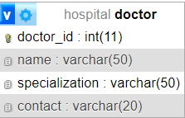

#### 2.2 Patient Table

The patient table is really important because it helps us keep track of all our patients and their medical information. We have details like their ID, name, gender, and contact information, which helps us build a complete profile for each patient. The patient ID is like a special code for each patient, which helps us connect their information with other parts of the database. This makes it easy to link everything together and find the right information when we need it.

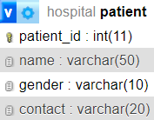

#### 2.3 Appointment Table

We use the appointment table to schedule appointments between doctors and patients. Each appointment has a special ID number, and we keep track of which doctor and patient are involved using their own ID numbers. This helps us make sure everyone knows when and where they need to be. We also include details like the date and time of the appointment to make sure everything runs smoothly at the clinic.

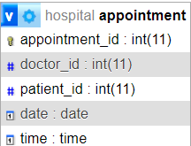

***Relations -:***

### Doctor-Patient Relationship:

* **Description**: This relationship indicates how doctors and patients are connected in the database.
* **Type**: Many-to-Many
* **Explanation**: In this scenario, one doctor can have many patients, and conversely, one patient can consult with multiple doctors. This flexibility allows patients to seek treatment from different doctors based on their health concerns, while doctors can treat multiple patients with various medical conditions.

### Doctor-Appointment Relationship:

* **Description**: This relationship highlights the connection between doctors and appointments.
* **Type**: One-to-Many
* **Explanation**: Here, each appointment is associated with one doctor. While a doctor can have multiple appointments scheduled, each appointment is specifically tied to one doctor. For instance, Dr. Smith might have several appointments throughout the day, but each appointment is specifically with Dr. Smith.

### Patient-Appointment Relationship:

* **Description**: This relationship outlines how patients and appointments are linked in the database.
* **Type**: One-to-Many
* **Explanation**: Each appointment is linked to one patient, implying that while a patient can have multiple appointments scheduled, each appointment is specific to one patient. For instance, a patient may have regular check-ups or appointments for different medical issues, but each appointment is tailored to that particular patient's needs.

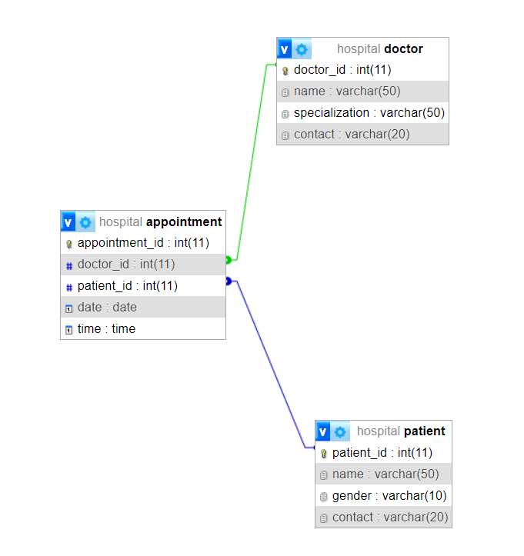

#### 2.4 Staff Table

The staff table is like our directory of everyone who works at the clinic, from nurses to receptionists. We keep important details like their name, job title, and contact information here. Each staff member gets their own special ID number, which helps us keep everything organized and makes it easier to communicate with everyone who works at the clinic.

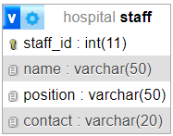

#### 2.5 Room Table

To make sure we're using our rooms wisely, we created a room table. Here, we keep track of things like the room number, what type of room it is, and whether it's available or not. This helps us decide which room to use for patients or medical procedures. Each room has its own special number, which helps us keep track of them easily.

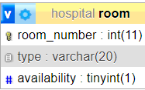

3) **Data Population:** We filled our database with pretend information about doctors, patients, appointments, staff, and rooms to mimic what happens in a real clinic. This lets us test our system thoroughly and make sure it can handle all the different tasks a clinic might have, making it reliable and sturdy.

**4) Functionality Implementation:**

**Appointment Scheduling**: Our system has a simple way for people to book appointments with doctors. They just fill out a form, pick a date and time they like, and they get a confirmation message. It's easy and helps keep everything organized.

**Staff Management**: We made a special tool to help manage the staff. This lets the people in charge assign jobs, keep track of everyone's contact details, and see how well everyone is doing at their work. This helps the staff stay organized and do their jobs well.

**Room Availability**: Our system keeps track of which rooms are free and which ones are being used. This helps the clinic staff know where to put patients and where to do medical procedures. It's like a map of the clinic that's always up-to-date, making things run smoothly.

**Conclusion:** Our project created a great database system for Hospital Management System. It's easy to use and can handle a lot of different tasks. We combined smart database design with simple ways for people to interact with it. In the future, we'll keep improving it to match the needs of clinics as they change and grow.

**Future Work:**

**Feature Expansion**: We want to add more cool features to our system, like ways to manage billing, keep track of patients' medical histories, and control the inventory of medical supplies. This will make the system even more useful for clinics.

**User Interface Enhancement:** We'll keep working on making the system easy and fun to use. We'll listen to feedback from users and try different designs to make sure everyone can use it easily, whether they're clinic staff or patients.

**Quality Assurance**: We'll keep testing our system to make sure it works well, keeps data safe, and doesn't have any bugs. We'll also keep updating it to use the latest technology and make sure it follows the best practices for building software.

**ERD-:**

